Gabriel Neely

Temple University

Department of Geography/Urban Studies

Population Geography

Professor Bradley Gardner

Bulgaria: A growing and shrinking population

An investigation of Bulgaria’s changing demographics with an emphasis on the Romani minority and attitudes towards Asylum Seekers

**Introduction**

Bulgaria is a country often associated by Americans with The Former Eastern Bloc or Viktor Krum, the Bulgarian Wizard from Harry Potter and The Goblet of Fire. Bulgaria is in fact much more than these two things. Bulgaria is a member of both NATO and the EU and is currently playing a major role in Europe’s refugee crisis. This essay however, seeks to examine the changing demographics of Bulgaria, which has the World’s fastest shrinking population. There is nevertheless a growing minority in the country, the Romani, often referred to in many western countries as *Gypsys*. This ethnic group is among (if not the most) marginalized group in Europe. Bulgaria has gained a reputation internationally as having the most discriminative policies towards this group. However, as the country’s ethnic Bulgarian population shrinks due to low birth rates and outward migration, the Romani are beginning to make up a larger proportion of the population due to their higher birth rates. This paper seeks to investigate the effects of outward migration, the social aspects of the growing Romani minority and the Republic of Bulgaria’s policies toward this group. An analysis of the causes of outward migration and growth of the Romani population will be used to draw conclusions as well as create an image for what Bulgaria’s demographic future will look like. Another group which is facing discrimination in Bulgaria are Asylum seekers and refugees who are using Bulgaria as a transit country on their route to Western Europe. Despite Bulgaria’s dwindling population, the government is responding more aggressively to this issue, which could possibly accommodate their demographic changes, in favor of a nationalist stance. A brief overview of immigration to Bulgaria will be discussed although the numbers are somewhat insignificant when considering the rates of emigration.

**Social Context**

The Republic of Bulgaria is a parliamentary republic on the Balkan Peninsula in southeastern Europe bordering Romania, Serbia, The Former Yugoslav Republic of Macedonia, Greece and Turkey. Historically the country has been a part of both the Byzantine and Ottoman Empires and was freed from the “Turkish Yoke” the name that most ethnic Bulgarians use for the centuries under Ottoman rule. Bulgaria became autonomous from the Ottomans through the help of Russia, a country who shared both its Slavic origins, Cyrillic alphabet (which was invented in Bulgaria) and Orthodox religion. This independence was seen as victory for Christianity in a way that Bulgaria was now allied with its Christian European neighbors. In the Balkan Wars of the early 1900s the young nation lost territory several times, adding to the country’s nationalism and fear of a foreign takeover. Although Bulgaria would not have been successful in gaining independence without the help of Russia they did fight on the Central and Axis powers in both world wars against Russia. After the fall of communism and Bulgaria’s status as a Soviet satellite state, relations between the two countries have varied. From 1946 to 1990 the country was a communist state known as The People’s Republic of Bulgaria. In 2004 Bulgaria became a member of NATO and three years later (along with Romania) a member of the European Union. Currently, the president Rumen Radev is pro-Russian as is the Prime Minister Boyko Borisov who has gained a reputation as both an anti-immigrant and anti-Roma politician. The political changes in the republic have had long lasting effects on the economy which switched from a centralized planned economy to a free market economy similar to other countries which came out from under The Soviet Union’s sphere of influence. Despite the 2008 economic crisis and a high emigration rate, Bulgaria’s economy is slowly growing in several sectors, which include energy, agriculture and tourism. Although Bulgaria has close trade ties with other EU states it still remains heavily reliant on Russia for energy. The Central Intelligence Agency’s World Factbook states that in 2017 Bulgaria’s unemployment rate was 7.7%. Other sources have said that this could be as low as 4.4%. The unemployment rate is often skewed as the unemployment rate among different ethnic groups in the country varies greatly. Among Bulgarians and most minority groups these statistics hold true, however, among the Roma unemployment is estimated to be as high as 89%. Of the 7.05 million people residing in Bulgaria 76.8% identified as Bulgarian, 8.2% as Turkish, 4.4% as Romani (although this number is likely much higher) and 0.7% as other.[1] The majority of these groups speak their respective languages (Bulgarian, Turkish and Romani) with many Romani often registering Bulgarian or Turkish as their first language. Bulgaria is officially a secular state; however, Bulgarians are overwhelmingly Orthodox Christians while the Turkish population is mainly Muslim. The Romani tend to take the religion of the community in which they are a minority, whether it be a Bulgarian or Turkish settlement.

According to the World Bank, Bulgaria is an upper-middle-income economy. Similar to many other former Eastern Bloc states, Bulgaria is considered to be an Emerging and Developing country, this is also known as a transition economy (a centrally planned economy shifting to a free market).

Our modern society has created a binary image of our world in that it recognizes a developed and developing world. I would argue that this approach is precarious in the case of Bulgaria because the country does not completely fit into either category. The binary image of our world would assume the idea that the developed world must ‘support’ or ‘help’ the developing world. Bulgaria is considered more and more of a developed country every year, however, there are still a plethora of institutional problems such as corruption and discrimination which need to be addressed. The more Bulgaria develops (and the more it becomes considered a developed country internationally) the less likely these issues are to be addressed. The transitional emerging economy of Bulgaria puts it (along with many other former communist states) at risk of losing global attention due to the ambiguity that the developing and developed world binary has given to it.

**Charts, Maps and Statistics**

In regard to the rest of the World, Bulgaria’s statistics show an unsustainable population trend. Deaths exceed births which along with emigration from the country, is causing a rapid population-decline, a common trend for many eastern European countries. The Central Intelligence Agency lists 226 countries ranked by their Crude Birth Rates, Bulgaria is far behind many of the countries which surround it. Bulgaria does rank above Germany, yet, Bulgaria does not have the inward flow of migrants that Germany does, that it requires to sustain its population size. The replacement rate of 2.0 which is required to sustain a population has not been recorded in Bulgaria since 1980s. The Mortality Rate (Crude Death Rate) of Bulgaria is about 15 deaths per 1,000 people, giving Bulgaria the highest Mortality Rate among European countries (in and outside of the EU). These statistics (see Appendices A,B and C) show that Bulgaria’s population has been on a rapid decline since the fall of communism.

**Country Policies and Campaigns**

1. **Fertility/ Population growth policy**

Since the 1980’s the Bulgarian governments have been attempting to address the issue of population decline. The population decline in Bulgaria is reflective of two factors. One being low birth rates, which are more common among ethnic Bulgarians as opposed to the higher birth rates of the Turkish and Roma minorities. The second is the large wave of emigrants who left the country in search of work after the fall of communism and even more after Bulgaria’s accession into the EU. One early policy of the government of the mid 80s was to make abortions illegal (until after the third child) and financial incentives which increased with each child. However, the policies were intended for the country’s ethnic Bulgarian population, which despite the incentives remained a population which averaged around one child per woman. The Turkish and Romani communities tended to have larger families which often exceed three children, due to this the incentives ended in 1985.[2] The attitudes of Bulgaria’s fertility policies towards Turks has much deeper roots in the country’s history as a part of the Ottoman Empire. This paper however, will focus on the Romani, a group which suffers from discrimination world-wide. Bulgaria, along with several other eastern European countries, is known to have the most radical policies towards this minority.

The Romani (often referred to as Gypsies) are an ethnic group which who can be found on several continents, mainly Europe, who originate from Northern India. The population of the Romani is estimated to be anywhere between two and twenty million (which shows how strong their representation is in global society). However, it is extremely difficult to calculate this population due to the various sub-groups of the Romani and the fact that many assume the nationality of the country where they are living. The western image of the Romani is of a nomadic group who are associated with poverty and criminality. Of the countries where Romani make up a significant percentage of the population Bulgaria is estimated to have the highest percentage (around 10% as opposed to the National census which places them at 4.4%). The Roma have been recorded in Bulgarian history since around the 13th century. In Bulgaria, as in many other countries, the Roma are often treated as secondary citizens. This means they have higher chances of being denied jobs and far less access to education and health-care than the Bulgarian and Turkish populations.[3] Roma communities are often condensed into ghettos in larger cities with far poorer living conditions of the other ethnic groups in the city. These policies will need to be addressed in the near future as the changing demographics of the country are making the Roma minority more and more prevalent each year. As stated by The Balkanist magazine, the ethnic Bulgarian population has a total fertility rate of around 1.1 children per woman (per 1,000 population) while the Roma have a total fertility rate of 3.0 children per woman( the Turkish community falling in between). The current government is also seeking to provide pro-natalist financial incentives similar to those of previous decades but only to families with secondary educations or higher, which would essentially mean no incentives for the country’s Roma minority, which has extremely low levels of education (due to segregated schools and lack of funding).[4] Bulgaria, despite its low birth rate, holds Europe’s place for the youngest average age of pregnancy due to a high tendency for teenage pregnancies among the Roma minority. The National Statistical Institute of Bulgaria placed this number at 27.8 years for the average mothers age (other sources place this number as low as 26 years).[5] Despite the higher prevalence of Roma women in maternity wards there are still many cases of hospitals segregating Roma women into separate wards. The Bulgarian government is for the most part ignoring the growing minority and hoping to increase the ethnic Bulgarian population not only through incentives but through the bringing back of ethnic Bulgarians living abroad. The government is currently expecting the country’s demand for more workers in sectors such as IT will bring back ethnic Bulgarians living abroad. At the same time, they are promoting work incentives for ethnic Bulgarians who have historically lived as minorities in countries like Moldova, to work in Bulgaria. In general terms, Bulgaria is placing less hope on the prospect of increasing its birth rates among ethnic Bulgarians (as this has been failing to work since the fall of communism) and turning its eyes towards bringing in Bulgarians from abroad. The Roma minority continues to have the highest birth rates among the countries minorities despite a lack of aid from the nationalist government. These policies are very representative of the country’s political attitudes towards people of a non-Bulgarian ethnic origin or of a non-Christian religious background. This is best represented through Bulgaria’s more recent stance on The Refugee Crisis.

1. **Anti-Refugee Policy**

When discussing migration in modern Bulgaria one cannot ignore the refugee crisis and the government’s attitudes towards it as Bulgaria is one of the leading transit countries for asylum seekers entering the European Union. Since the start of The Refugee Crisis in 2015, Bulgaria has served as a major transit country for asylum seeks crossing its borders with Turkey and Greece. As western European countries created stricter migration laws due to the high influx of refugees, more and more asylum seekers found themselves remaining in Bulgaria. According to the Asylum Information Database there were 3,700 asylum applications in Bulgaria in 2017, mainly from Afghanistan, Iraq and Syria. According to the Bulgarian National Statistics Institute, there were 25,597 immigrants who came to Bulgaria in 2017 and 31,586 emigrants who left (the number of immigrants includes refugees). Due to Bulgaria’s close historical ties with Russia and its time as an integral part of the Ottoman Empire, it is not surprising that the largest immigrant groups migrating to the country come from Russia, Ukraine and Turkey. Syria, follows behind in numbers of immigrants almost exclusively due to the refugee crisis (see Appendix D). According to a survey conducted by Lyuomir Kyuchukov, 47% of Bulgarians answers that they believed that the EU should not help refugees seeking asylum on its territory. Another 37% (adult citizens) answered that they fear people of other religions, which in this case would correspondingly be termed as xenophobia.[6] Reports have circulated about groups of vigilantes patrolling the Bulgarian-Turkish border, making citizen’s arrests (which are illegal in Bulgaria) of refugees crossing the border. Reports of both maltreatment as well as humane treatment of refugees caught by these groups have been reported. However, the main group patrolling this border, known as BNO Shipka, is a self-declared nationalist and anti-Islamic movement, which the group defines as an anti-criminal organization. The problem is that the vast-majority of these refugees are simply using Bulgaria as a transit route. Many economic migrants from countries like Afghanistan do not see Bulgaria as a place of opportunity but as a crossroads on their way to western Europe and the Schengen Zone (which Bulgaria is not a part of). The government has condemned the vigilante groups but at the same time is taking similar measures itself. Prime Minister Boyko Borissov has constructed border walls and reinforced border police as a means of keeping refugees out of Bulgaria and the EU. Essentially, the policies of Borissov are popular among older citizens in the country. The Bulgarian national identity (of ethnic Bulgarians) is Slavic and Orthodox, the roots of these policies lie in the country’s history of being a part of the Ottoman Empire and the fear of a disappearing Bulgarian identity, which the low birth rates play a major role in.

Bulgaria is not a country of migration but a country of emigration. Although the country does draw in thousands of immigrants every year it does not break even with the numbers of emigrants. Bulgaria has two categories of migrants. Long-Term migrants, who are able to stay in the country for one year with their work permit with a possibility of extension. The other would be permanent migrants who hold residency in the country for an undetermined period of time. In 2005, there were 1,060 registered Long-Term Migrants. Many of these migrants came in small numbers from western countries such as The United Kingdom, The United States and Germany. These numbers show us that Long-Term migrants are people likely from developed countries working for a short period of time in a developing or emerging economy, as seen all over the world. One statistic which validates this is that among Long-Term migrants, 21% had a higher education, while among Bulgarians this number was at 12%.[7] The Long-term migrants who do not hold a higher education are often from countries such as The Former Yugoslav Republic of Macedonia, Serbia, Ukraine and China. The largest group of Long-Term migrant workers was from Turkey. This is unsurprising considering that Turks represent the largest minority in the country and still hold close ties to Turkey making it easier for Turkish citizens with relatives in Bulgaria to find work in the country. When considering which jobs migrants do in Bulgaria, it can be assumed that highly educated Long-Term migrants are coming to Bulgaria for short-term (likely less than five years) skilled work while others are coming to work in unskilled positions. The need for unskilled immigrants however, is in essence, unnecessary when considering the unemployment rate among the Roma communities in the country.[8]

The process of attaining Bulgarian citizenship is relatively difficult when one does not have Bulgarian ancestry or a parent who is a Bulgarian citizen. One must reside in the country for at least five years, have an income that one can support themselves on, an understanding of the Bulgarian language (by Government standards) and not have been convicted of a crime by Bulgarian courts. Bulgaria does have a loop-hole in obtaining citizenship which involves investment in the country. Many Russian and Ukrainian immigrants likely attain citizenship through this as they often buy properties along the country’s Black Sea coast. Bulgarian law does grant a person who has been granted humanitarian status in the country the prospect of citizenship after five-years if they meet the country’s naturalization laws.

Ultimately, the Bulgarian government is seeking to bring back both skilled and unskilled Bulgarians from abroad, retain its influx of wealthy expatriates seeking to purchase land on the Black Sea coast and halt the flow of refugees who are mainly passing through the country. Along with this the Bulgarian government is looking for ways to make Bulgaria a more attractive place to *stay* in for work as a means of preventing youth-emigration. Although the integration of both Roma and Refugees into Bulgarian society could have countless benefits to both the country’s demographic future and economy, it seems unlikely. In December 2018 the United Nations will hold a summit in Morocco which will be called The Global Compact for Migration (or The Global Compact for Safe, Orderly and Regular Migration), Bulgaria, along with several other EU Member states, has stated that it will not be attending.

**Reflection Part 1**

When reflecting on the population policies that Bulgaria has used in the past and is currently using, one can identify the use of normalizing power, epistemic violence and repressive policies in almost every policy. Normalizing power seeks to assert the highest level of social control over a population through ideas which eventually (through the process) become seen as normal. Bulgaria has effectively done this through its historical stance towards the Islamic world which has normalized the idea that Islam is dangerous to the Bulgarian national identity. Through this, repressive policies such as those against refugees have evolved organically among a population that has come to see Islam as a danger to their society as a norm. Repressive policies against non-Bulgarian identities have been evolving ever since the Republic’s independence from the Ottoman Empire. One primary example is a government act in the mid 1980s which sought to “Bulgarize” all non-Bulgarian/Slavic family names, that being those of the Turkish and Roma minorities. A form of forced assimilation to a Bulgarian national identity. Epistemic violence in the country is wide spread in several forms. Marginalized groups, mainly the Roma, are not provided with the same educational opportunities as ethnic Bulgarians. The Bulgarian government sees the Roma community’s higher birth-rate as a danger to Bulgaria’s demographic future. However, the Bulgarian government is a victim of its own violence and repressive power in this sense. The Roma community is not provided with the same public-health education, health care or general education as the rest of the population. Thus, it is not surprising that they have higher birth-rates when social services such as contraception and family planning are often not available to them in their respective communities. Any more repressive policies in Bulgaria would look similar to those of their communist past when abortions were not legal until after the third child and if stricter laws were placed on freedom of movement to prevent emigration. However, as Bulgaria is now a member of the EU the possibility of these repressive policies returning are highly unlikely.

**Reflection Part 2**

Normalizing power effects each and every one of us in our everyday lives whether we have come to realize it or not. In some ways it works to make the world a more humane and efficient place and in other ways (such as those discussed in the case of Bulgaria) they have the opposite effect. In Bulgaria, much of the anti-Islamic sentiment comes from the older generations. Younger generations however, through normalizing power, are more likely to see a globalizing society. Through social media, film and a more ethnically diverse global society, the younger generations are becoming more adapt to each other’s cultures. This form of normalization is what could lead countries like Bulgaria to a more liberal and less violent future.

These principles operate constantly in our everyday lives, throughout this course I have related to how they have functioned in my day to day life as a college student. Small things such as showing my ID when entering a building to being under the impression that it is necessary for me to vote in elections are some examples. One example, which I saw as a way of me overcoming normalized power was joining the Peace Corps. Although the Peace Corps does not always require a background in a specific field (as in my case), I find that we are normalized to assume that our career must be in the field in which we receive our degree. As a double major in Geography/Urban Studies (GUS) and German I always thought that I was being pushed in the direction of careers such as Geographic Information Systems (GIS), Research, German as a second language education or towards a master’s Degree. This normalized power did not come from my University or from either of the departments in which I was studying but rather from a societal norm. A bachelor’s degree is meant to be multi-disciplinary in most cases and serve as a gateway to give students the knowledge to take the next step in their education or career. However, society often dictates that we follow our degree into a specific field. For example, nursing students becoming nurses in a hospital or History students becoming secondary education teachers. After committing to becoming an English as a Second Language Teacher in Kosovo once I receive my degree, I realized that I almost fell victim to the normalization of power which I had not realized was dictating my future plans. Before taking this class, I was always concerned about things like my lack of fluency in GIS or my hesitations about graduate school. When I asked a professor from my primary major (GUS) to write me a letter of recommendation, I was met with no questions as to why I was not pursuing a career that was more closely related to my major, but rather encouragement. I then realized that my personal doubts about my post-graduation plans were a product of a normalized power which I had previously not perceived. Through this, I was able to interrupt a normalized power that has been highly present in my life over the course of my bachelor’s degree. I would not consider this at all to be a form of repressive power, which would likely be a law which requires people to work in their field of study.

**Conclusion**

Bulgaria could likely bring a stop to or at least a decrease to its rapid population decline through more liberal political policies, that being towards the country’s minorities as well as asylum seekers. If Bulgaria remains in its current state, the country’s predicted population of around five million people by the year 2050 will be inevitable. If the current birth rates among the ethnic groups in the country remain the same, the Roma will also by this time constitue the majority in the country. The decisions and policies which are being enacted by Bulgaria’s right-wing government are embedded in the country’ history, which sees Bulgaria as a bastion of Christianity bordering the Islamic world. Bulgaria’s demographic changes and policies are the result of many factors which include its economic and political past, its role as an EU member and the ethnic Bulgarian’s fear of losing their national identity as the country’s minority groups grow and the ethnic Bulgarian population declines.

**Works Cited**

*Anti-Roma Protests Escalate in Bulgaria.(Report)*.

Colborne. Michael. “The Far Right’s Quixotic Fight Against “Demographic Catastrophe” in Bulgaria.” The Balkanist. October. 4. 2017. Accessed November 18, 2018.

Cheresheva, Mariya. “’Roma Segregated’ in Bulgarian Maternity Wards. BalkanInsight. 18/12/17. Accessed 18.November 2018.

Cviklova, Lucie.*Direct and Indirect Racial Discrimination of Roma People in Bulgaria, the Czech Republic and the Russian Federation* Routledge. doi:10.1080/01419870.2015.1042892.

Creed, Gerald W. “The Bases of Bulgaria’s Ethnic Policies.” City University of New York Graduate School. Accessed November 18, 2018.

Danova,-Roussinova, Savelina. *“Roma in Bulgaria: Human Rights and State Policies.”* Accessed November 18, 2018.

Dimitrova, Snezhanka. *“Employment and Working conditions of Migrant workers- Bulgaria”*. European Foundation for the Improvement of Living and Working Conditions. May 30th 2017. Accessed November 19th 2018.

Ivanov, Martin and Adam Tooze.*Convergence Or Decline no Europe's Southeastern Periphery? Agriculture, Population, and GNP in Bulgaria*.

Kitova, Tanya. *“Birth and Abortion Rates among Roma and Bulgarian Ethnic groups In Bulgaria”.* Research Gate. January 2015. Accessed November 18, 2018.

Kyuchukov, Lyubomir. *“Impact of the Refugee Crisis on Bulgarian Society and Politics: Fears but no hatred.”* Friedrich-Ebert Stiftung. Accessed November 19. 2018.

Masseria, Cristina, Philipa Mladovsky, and Cristina Hernández-Quevedo.*The Socio-Economic Determinants of the Health Status of Roma in Comparison with Non-Roma in Bulgaria, Hungary and Romania*. doi:10.1093/eurpub/ckq102.

Natalia Stoyanova.*The Challenges of Demographic Aging and Migration of Population in Bulgaria*.

“National Demographic Strategy of The Republic of Bulgaria 2006-2020”. 2007. Accessed Nov. 16. 2018.

Roma Survey – Data in focus. Poverty and Employment: the situation of Roma in 11 EU Member states. European Union Agency for fundamental rights. 2014

**Appendix**

1. **Population Statistics for Bulgaria in 2017**

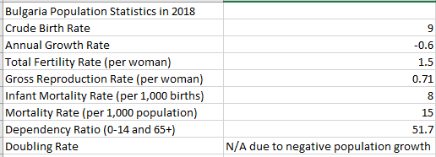

1. **Bulgaria’s Age Distribution by Sex in 2018**

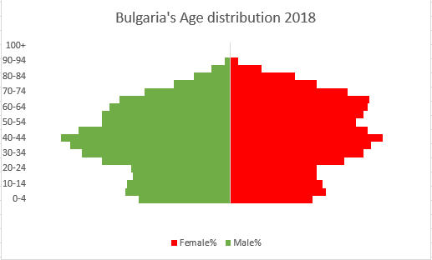

1. **Bulgaria’s Population from 1990 to 2018**

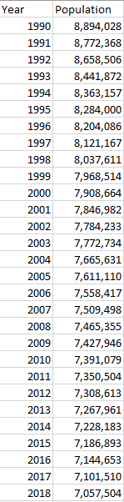

1. **Distribution of the 4 largest Emigrant and Immigrant groups in Bulgaria**

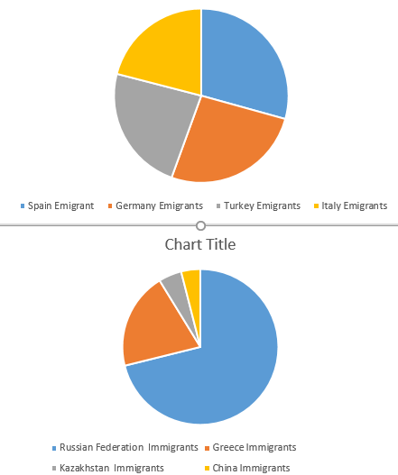

1. **The four main countries of Immigration to Bulgaria – Russia, Ukraine, Turkey and Syria – Syria is not shown on the table above since the majority of these Immigrants are temporary Asylum Seekers.**

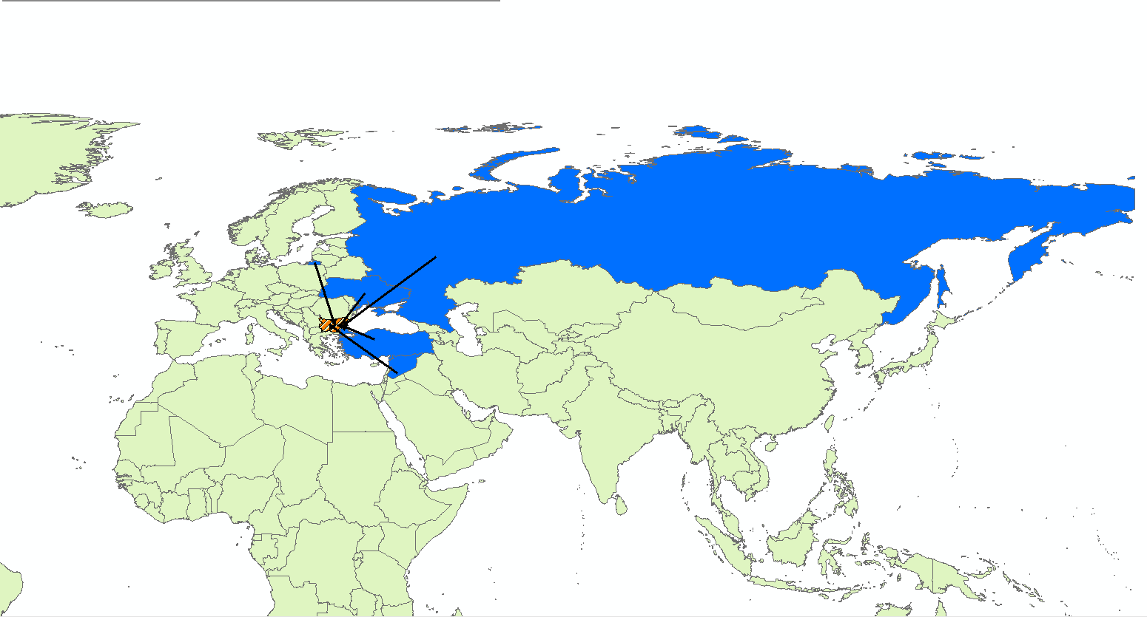

1. Central Intelligence Agency World Factbook – Other minortiies in Bulgaria include Russians, Armenians and Vlach (Romance language speakers who have origins in the Thrace Valley region)
2. Creed, Gerald W. “The Bases of Bulgaria’s Ethnic Policies”. Pg. 19
3. Danova-Roussinova, Savelina. *“Roma in Bulgaria: Human Rights and State Policies”.*
4. Coloborne, Michael. “The Far Right’s Quixotic Fight Against “Demographic Catastrophe” in Bulgaria.
5. Kitova, Tanya. *“Birth and Abortion Rates among Roma and Bulgarian Ethnic groups in Bulgaria”.*
6. Kyuchukov, Lyubomir. *“Impact of the Refugee Crisis on Bulgarian Society and Politics: Fears but No Hatred.” Pg. 7.*
7. Dimitrova, Snezhanka. “*Employment and Working conditions of migrant workers- Bulgaria”.*
8. Unemployment rates among the Roma are extremely difficult to estimate since they are often informally declared self-employed, left out of the census or identify as Bulgarian or Turkish.